AUTOMATIC HELMET AND LICENSE PLATE

RECOGNIZATION USING YOLOV5 WITH INSTANT

E-CHALLAN INTIMATOR USING DEEP LEARNING

***A Project Report submitted in the partial fulfilment of the requirements for the award of the Degree of***

# BACHELOR OF TECHNOLOGY

IN

COMPUTER SCIENCE AND ENGINEERING

**Submitted By**

Y. SAKETHKUMAR **(Regd.No: 20471A05N7)**

B. RANGA SAI KARTHIK **(Regd.No: 20471A05K3)**

K. MANIKYA RAO **(Regd.No: 21475A0511)**

**Under The Esteemed Guidance Of**

**DR.S. Siva Nageswara Rao M. Tech, Ph.D**

**Professor**

**Department of Computer Science and Engineering**



**Department of Computer Science and Engineering**

**NARASARAOPETA ENGINEERING COLLEGE**

**(Approved by AICTE & Affiliated to JNTU, KAKINADA, Accredited by NAAC & NBA)**

**Yalamanda, Narasaraopet, PALNADU (Dt.), A.P. 2020-2024**

**NARASARAOPETA ENGINEERING COLLEGE**

**(Approved by AICTE & Affiliated to JNTU KAKINADA, Accredited by NAAC & NBA)**

**Yalamanda, Narasaraopet-522601, Palnadu (Dist) A.P**

# DEPARTMENT OF COMPUTER SCIENCE AND ENGINEERING



**CERTIFICATE**

**This is to certify that the project that is entitled with the name “AUTOMATIC HELMET AND LICENSE PLATE RECOGNITION USING YOLOV5 WITH INSTANT E-CHALLAN INTIMATOR USING DEEPLEARNING” is a bonafide work done by the team** Y. Saketh Kumar (20471A05N7), B.R.S.Karthik(20471A05K3), K. MANIKYA RAO (21475A0511) in partial fulfillment of the requirements for the award of the degree of BACHELOR OF TECHNOLOGY in the Department of COMPUTER SCIENCE AND ENGINEERING during 2023-2024.

**PROJECT GUIDE PROJECT ORDINATOR**

Dr.S.Siva Nageswara Rao M.Tech.Ph.D. M.Sireesha ,M.Tech .Ph.D.

**Professor  Assoc .Professor**

**HEAD OF THE DEPARTMENT EXTERNAL EXAMINER**

**Dr. S.N. Tirumala Rao, M. Tech., Ph.D.**

**Professor & HOD**

**DECLARATION**

We declare that this project work titled “AUTOMATIC HELMET AND LICENSE PLATE

RECOGNIZATION USING YOLOV5 WITH INSTANT E-CHALLAN INTIMATOR USING

DEEP LEARNING” is composed by ourselves that the work contain here is our own except where explicitly stated otherwise in the text and that this work has been submitted for any other or professional qualification except as specified.

Y. SAKETH KUMAR (20471A05N7)

B.RANGA SAI KARTHIK (20471A05K3)

K. MANIKYA RAO (21475A0511)

# ACKNOWLEDGEMENT

We wish to express my thanks to carious personalities who are responsible for the completion of the project. We are extremely thankful to our beloved chairman sri **M.V.Koteswara Rao,B.Sc.,** whotook keen interest in us in every effort throughout this course. We owe out sincere gratitude to ourbeloved principal **Dr.M.Sreenivasa Kumar, M.Tech., Ph.D., MISTE., FIE(I).,** for showing his kind attention and valuable guidance throughout the course.

We express our deep felt gratitude towards **Dr.S.N.Tirumala Rao, M.Tech.,Ph.D.** HOD of CSE department and also to our guide **Dr.S.Siva Nageswara Rao,M.Tech.,Ph.D.** professor of CSE department whose valuable guidance and unstinting encouragement enable us to accomplish our project successfully in time.

We extend our sincere thanks towards **Mrs. Sireesha.M, M.Tech.,Ph.D.** Associate professor & Project coordinator of the project for extending her encouragement. Their profound knowledge and willingness have been a constant source of inspiration for us throughout this project work.

We extend our sincere thanks to all other teaching and non-teaching staff to department for their cooperation and encouragement during our B.Tech degree.

We have no words to acknowledge the warm affection, constant inspiration and encouragement that we received from our parents.

We affectionately acknowledge the encouragement received from our friends and those who involved in giving valuable suggestions had clarifying out doubts which had really helped us in successfully completing our project.

**By**

Y.SAKETH KUMAR (20471A05N7)

B.RANGA SAI KARTHIK (20471A05K3)

K.MANIKYA RAO (21475A0511)

[](https://www.nrtec.in/)

**INSTITUTE VISION AND MISSION**

**INSTITUTION VISION**

To emerge as a Centre of excellence in technical education with a blend of effective student centric teaching learning practices as well as research for the transformation of lives and community,

**INSTITUTION MISSION**

M1: Provide the best class infra-structure to explore the field of engineering and research

M2: Build a passionate and a determined team of faculty with student centric teaching,imbibing experiential, innovative skills

M3: Imbibe lifelong learning skills, entrepreneurial skills and ethical values in the

students for addressing societal problems

[](https://www.nrtec.in/)

**DEPARTMENT OF COMPUTER SCIENCE AND ENGINEERING**

**VISION OF THE DEPARTMENT**

To become a centre of excellence in nurturing the quality Computer Science & Engineering professionals embedded with software knowledge, aptitude for research and ethical values to cater to the needs of industry and society.

**MISSION OF THE DEPARTMENT**

The department of Computer Science and Engineering is committed to

**M1:** Mould the students to become Software Professionals, Researchers and Entrepreneurs by providing advanced laboratories.

**M2:** Impart high quality professional training to get expertize in modern software tools and technologies to cater to the real time requirements of the Industry.

**M3:** Inculcate team work and lifelong learning among students with a sense of societal and ethical responsibilities.

[](https://www.nrtec.in/)

**Program Specific Outcomes (PSO’s)**

**PSO1:** Apply mathematical and scientific skills in numerous areas of Computer Science and Engineering to design and develop software-based systems.

**PSO2:**Acquaint module knowledge on emerging trends of the modern era in Computer Science and Engineering

**PSO3:** Promote novel applications that meet the needs of entrepreneur, environmental and social issues.

[](https://www.nrtec.in/)

**Program Educational Objectives (PEO’s)**

The graduates of the programme are able to:

**PEO1:** Apply the knowledge of Mathematics, Science and Engineering fundamentals to identify and solve Computer Science and Engineering problems.

**PEO2:** Use various software tools and technologies to solve problems related to academia, industry and society.

**PEO3:** Work with ethical and moral values in the multi-disciplinary teams and can communicate effectively among team members with continuous learning.

**PEO4:** Pursue higher studies and develop their career in software industry.

[](https://www.nrtec.in/)

**Program Outcomes**

**1.Engineering knowledge:**Apply the knowledge of mathematics, science, engineering fundamentals, and an engineering specialization to the solution of complex engineering problems.

**2. Problem analysis:**Identify, formulate, research literature, and analyzecomplex engineering problems reaching substantiated conclusions using firstprinciples of mathematics, natural sciences, and engineering sciences.

**3. Design/development of solutions:**Design solutions for complex engineering problems and design system components or processes that meet the specified needs with appropriate consideration for the public health and safety, and the cultural, societal, and environmental considerations.

**4. Conduct investigations of complex problems:**Use research-based knowledge and research methods including design of experiments, analysis and interpretation of data, and synthesis of the information to provide valid conclusions.

1. **Modern tool usage:**Create, select, and apply appropriate techniques,resources, and modern engineering and IT tools including prediction andmodeling to complex engineering activities with an understanding of thelimitations.
2. **The engineer and society:**Apply reasoning informed by the contextualknowledge to assess societal, health, safety, legal and cultural issues and theconsequent responsibilities relevant to the professional engineering practice.
3. **Environment and sustainability:**Understand the impact of theprofessional engineering solutions in societal and environmental contexts,and demonstrate the knowledge of, and need for sustainable development.

8**.Ethics:**Apply ethical principles and commit to professional ethics and responsibilities and norms of the engineering practice

9**.Individual and team work**: Function effectively as an individual, and as a member or leader in diverse teams, and in multidisciplinary settings.

10**.Communication**: Communicate effectively on complex engineering activities with the engineering community and with society at large, such as, being able to comprehend and write effective reports and design documentation, make effective presentations, and give and receive clear instructions.

11**. Project management and finance**: Demonstrate knowledge and understanding of the engineering and management principles and apply these to one’s own work, as a member and leader in a team, to manage projects and in multidisciplinary environments.

12**. Life-long learning**: Recognize the need for, and have the preparation and ability to engage in independent and life-long learning in the broadest context of technological change.

[](https://www.nrtec.in/)

**Project Course Outcomes (CO’S):**

**CO421.1:** Analyse the System of Examinations and identify the problem.

**CO421.2:** Identify and classify the requirements.

**CO421.3:** Review the Related Literature

**CO421.4:** Design and Modularize the project

**CO421.5:** Construct, Integrate, Test and Implement the Project.

**CO421.6:** Prepare the project Documentation and present the Report using appropriate method.

**Course Outcomes – Program Outcomes mapping**

|  |  |  |  |  |  |  |  |  |  |  |  |  |  |  |  |
| --- | --- | --- | --- | --- | --- | --- | --- | --- | --- | --- | --- | --- | --- | --- | --- |
|  | **PO1** | **PO2** | **PO3** | **PO4** | **PO5** | **PO6** | **PO7** | **PO8** | **PO9** | **PO10** | **PO11** | **PO12** | **PSO1** | **PSO2** | **PSO3** |
| **C421.1** |  | ✓ |  |  |  |  |  |  |  |  |  |  | ✓ |  |  |
| **C421.2** | ✓ |  | ✓ |  | ✓ |  |  |  |  |  |  |  | ✓ |  |  |
| **C421.3** |  |  |  | ✓ |  | ✓ | ✓ | ✓ |  |  |  |  | ✓ |  |  |
| **C421.4** |  |  | ✓ |  |  | ✓ | ✓ | ✓ |  |  |  |  | ✓ | ✓ |  |
| **C421.5** |  |  |  |  | ✓ | ✓ | ✓ | ✓ | ✓ | ✓ | ✓ | ✓ | ✓ | ✓ | ✓ |
| **C421.6** |  |  |  |  |  |  |  |  | ✓ | ✓ | ✓ |  | ✓ | ✓ |  |

**Course Outcomes – Program Outcome correlation**

|  |  |  |  |  |  |  |  |  |  |  |  |  |  |  |  |
| --- | --- | --- | --- | --- | --- | --- | --- | --- | --- | --- | --- | --- | --- | --- | --- |
|  | **PO1** | **PO2** | **PO3** | **PO4** | **PO5** | **PO6** | **PO7** | **PO8** | **PO9** | **PO10** | **PO11** | **PO12** | **PSO1** | **PSO2** | **PSO3** |
| **C421.1** | 2 | 3 |  |  |  |  |  |  |  |  |  |  | 2 |  |  |
| **C421.2** |  |  | 2 |  | 3 |  |  |  |  |  |  |  | 2 |  |  |
| **C421.3** |  |  |  | 2 |  | 2 | 3 | 3 |  |  |  |  | 2 |  |  |
| **C421.4** |  |  | 2 |  |  | 1 | 1 | 2 |  |  |  |  | 3 | 2 |  |
| **C421.5** |  |  |  |  | 3 | 3 | 3 | 2 | 3 | 2 | 2 | 1 | 3 | 2 | 1 |
| **C421.6** |  |  |  |  |  |  |  |  | 3 | 2 | 1 |  | 2 | 3 |  |

**Note: The values in the above table represent the level of correlation between CO’s and PO’s**

1.**Low level**

2.**Medium level**

3.**High level**

**Project mapping with various courses of Curriculum with Attained PO’s:**

|  |  |  |
| --- | --- | --- |
| **Name of the course from which principles are applied in this project** | **Description of the device** | **Attained PO** |
| C2204.2, C22L3.2 | Gathering the requirements and defining the problem, plan to develop a **Automatic helmet and license plate recognization using yolov5 with instant E-challan intimator using deep learning.** | PO1, PO3 |
| CC421.1, C2204.3, C22L3.2 | Each and every requirement is critically analyzed, the process model is identified and divided into **five modules** | PO2, PO3 |
| CC421.2, C2204.2,C22L3.3 | Logical design is done by using the unified modelling language which involves individual team work | PO3, PO5, PO9 |
| CC421.3, C2204.3,C22L3.2 | Each and every module is tested, integrated, and evaluated in our project | PO1, PO5 |
| CC421.4, C2204.4,C22L3.2 | Documentation is done by all our four members in the form of a group | PO10 |
| CC421.5, C2204.2,C22L3.3 | Each and every phase of the work in group is presented periodically | PO10, PO11 |
| C2202.2, C2203.3, C1206.3, C3204.3, C4110.2 | Implementation is done and the project will be handled by the t**he users to detect the helmet and license plates of people.** | PO4, PO7 |
| C32SC4.3 | **The physical design includes website for detecting the helmet and license plates of peoples.** | PO5, PO6 |

**ABSTRACT**

Due to the irregularity of traffic and the affordability of motorcycles, the number of accidents increased rapidly. Now it is a public duty to follow the traffic rules, but we just pay attention. Most use cases require human assistance, but automation is needed for better results. The Automatic Helmet Detection and Number Plate Recognition system presented in this study addresses critical aspects of road safety and law enforcement. This innovative system leverages computer vision and deep learning techniques to automatically detect whether motorcyclists are wearing helmets and recognize the number plates of vehicles in real-time. This yolov8 recognition system detects motor cycle riders without a helmet from .mov extension and records the vehicle license plate and driver and license plate images. The helmet detection component employs Region-Based convolutional neural networks (RCNNs) to analyse video or image streams from traffic surveillance cameras.

.

## INDEX

**S.NO** **CONTENT PAGE NO**

1. **INTRODUCTION** 1

1.1 Introduction 1

1. **LITERATURE SURVEY** 4

2.1 Literature survey 4

2.2 Deep learning 5

* 1. Applications of Deep learning 6

2.4 Classification 7

2.5 Needs of Data Pre-Processing 8

2.6 Deep learning Products 9

1. **SYSTEM ANALYSIS** 10
   1. Scope of the project 10
   2. Analysis 10

3.3 Existing System 11

3.4 Proposed System 12

* 1. Data Preprocessing 14

3.6 Data Cleaning 16

3.7 System Requirements 18

3.8 Feasibility Study 19

3.8.1Economical Feasibility 19

3.8.2 Technical Feasibility 19

3.8.3.Social Feasibility 19

**4 DESIGN** 21

4.1Data Flow Diagram 21

**5 IMPLEMENTATION** 21

|  |
| --- |
|  |
| **6 TESTING** 33  6.1 test cases 34 | |  |
| **7 OUTPUT SCREENS** 37    **8 CONCLUSION & FUTURE SCOPE** 37 | |  |
| **9 REFERENCES** 38 | |  |

5.1 Sample Code 21

**LIST OF FIGURES**

**S.NO LIST OF FIGURES PAGE NO** 1.Fig:1.1.1 Helmet Detection 2

2. Fig:2.6.1 YoloV5 model for object detection 9

3Fig:3.2.1Helmet detection and license plate extraction 11

4 Fig3.4.1 proposed system for helmet detection 13

5 Fig3.5.1 Data storage and management 14

6 Fig3.6.1 Data cleaning 16

7 Fig3.6.2 Characters recognition 17

8 Fig3.7.1 Software requirements 18

9 Fig4.1.1 Modelling 21

10 Fig5.1 Shows the architecture of SMTP 27

11 Fig6.1 Image for helmet detection 34

12 Fig6.1.2 Helmet detected 34

13 Fig6.2 Captured images for detection 35

14 Fig6.2.1 Helmet detected 35

15 Fig6.3 Captured image at traffic 36

16 Fig7.1 Identifying a person who has no helmet 37

17 Fig7.2 Detected person with a helmet 37

18 Fig7.3 Extracting the text from number plate 38

**1.INTRODUCTION**

### 1.1 Introduction

In an era where road safety and law enforcement have become paramount concerns, the development of innovative technologies plays a pivotal role in ensuring the well-being of citizens and the efficient functioning of traffic systems. Among these technologies, Automatic Helmet Detection and Number Plate Recognition have emerged as indispensable tools for addressing these critical issues. Road accidents, particularly those involving motorcycles, pose a significant threat to public safety. While the use of helmets has proven to be one of the most effective measures in reducing the severity of head injuries in accidents, many riders fail to adhere to helmet usage laws. This lax compliance necessitates the need for a proactive solution. Simultaneously, the recognition of vehicle number plates is essential for identifying vehicles, managing traffic violations, and ensuring the legitimacy of vehicles on the road.

Automatic Helmet Detection and Number Plate Recognition are two distinct yet interconnected components of a system designed to tackle these challenges. Through the fusion of computer vision, deep learning and image processing technologies, this system has the capability to detect whether motorcyclists are wearing helmets and recognize the alphanumeric characters on vehicle license plates in real-time. The implications of such a system are far-reaching. It not only facilitates the enforcement of helmet usage laws and promotes road safety but also aids law enforcement agencies in efficiently identifying and tracking vehicles. Moreover, the technology provides a means to manage traffic violations effectively, ultimately enhancing the overall functioning of traffic systems. It is challenging for the traffic police to compile a challan, allocate funds to a particular infringement, and send a challan to their mobile number because there are many people who break the law.

As they are not informed of the infraction, many of these people are unaware of it and the fine that must be paid. This problem is addressed, and the public is made aware of the violation,by using the E-Challan generator. This system will send the violator an SMS or email. This introduction serves as a prelude to an exploration of the methodologies, and the benefits, and potential applications of Automatic Helmet Detection and Number Plate Recognition, offering insights into how this innovative technology can play a vital role in making our roads safer.

.

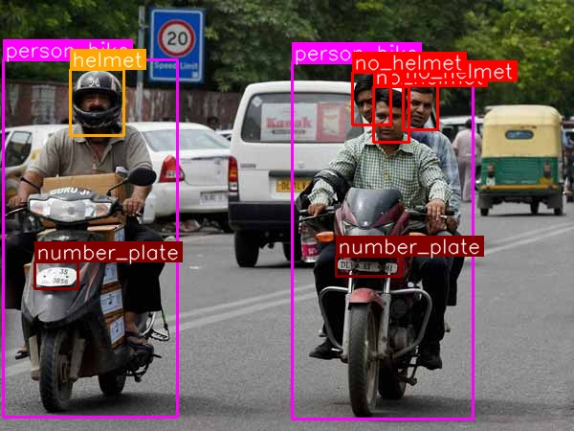

Fig 1.1.1 Helmet Detection

YOLO or You Only Look Once, is a popular real- time object detection algorithm. YOLO combines What was once a multi-step process, using a single neural network to perform both classification and Prediction of bounding boxes for detected objects. This algorithm is popular because of its speed and accuracy . It has been used in various applications to detect traffic signals, people, parking meters and animals. The algorithm divides imagines into a grid system. Each cell in the grid is responsible for detecting objects within itself.

YOLO Versions YOLOV1 referred to as just YOLO, can perform faster than real-time object detection at 45 frames per second, making it a great choice for application that require real-time detection YOLO. YOLO is able to predict all objects in one forward pass. The Yolo v2 can process images at 40-90 FPS. YOLOV3 allows us to easily trade off between speed and accuracy, just by changing the model size without any retraining.

YOLOV4 also based on the darknet , with a real time speed of 65 FPS on the Tesla V100, beating the fastest and most accurate detectors in terms of both speed and accuracy.YOLOV5 is extremely fast and light weight than YOLO V4, while the accuracy is on par with the YOLOV4 benchmark..

The basic concepts that are included in it are Optical Character Recognition(OCR), Open CV and CNN Convolution Neural Network . R-CNN is a two stage detection algorithm first stage identifies a subset of regions in an image that might contain an object. Second stage classifies the object in each region.

R-CNN: REGIONS WITH CNN FEATURES

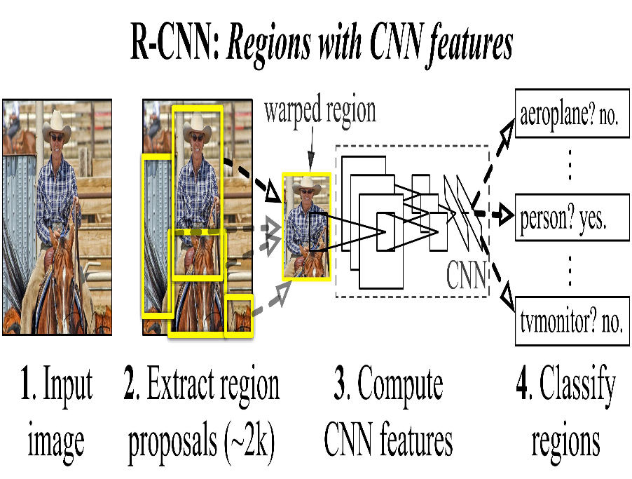

**R-CNN**

* R-CNN is a two-stage detection algorithm. The first stage identifies a subset of regions in an image that might contain an object. The second stage classifies the object in each region.
* Models for object detection using regions with CNNs are based on the following three processes:
  + Find regions in the image that might contain an object.
  + These regions are called region proposals.
  + Extract CNN features from the region proposals.
* Classify the objects using the extracted features
  + Applications include:
  + Autonomous driving.
  + Smart surveillance systems.
  + Facial recognition.

**OPENCV**

* OpenCV is a huge open-source library for computer vision,machine learning, and image and processing.
* It can process images and videos to identify objects, faces, or even the handwriting of a human.
* These algorithms can be used to detect and recognize faces, identify objects, classify human actions in videos, track camera movements, track moving objects, extract 3D models of objects, stitch images together to produce a high-resolution image of an entire scene, etc.

1. **LITERATURE SURVEY**

**2.1 Literature survey**

**Title**: DWCA-YOLOv5: An Improve Single Shot Detector for Safety Helmet Detection **Journal**: International Journal of Science and Research (IJSR)

**Methodology:**

An enhanced YOLOv5 helmet wearing detection method is suggested in this paper. In their research, Zhang Jin and Jianming Zhang suggested a better way to detect YOLOv5 helmet wear. First, the dataset for the scene of the self-made construction activity is dimensionally clustered using the Kmeans++ algorithm to increase the size matching degree of the a priori anchor box; The second step is to incorporate the Depth wise Coordinate Attention (DWCA) mechanism into the backbone network in order to capture more detailed information. By doing this, the network will be able to learn the weight of each channel on its own and improve information sharing between features, improving its ability to tell apart foreground from background.

The same number of test sets are employed under identical configuration conditions to confirm that the proposed algorithm produces better results, and at this time, various well known object identification networks are used for comparative experiments: faster RCNN, SSD, and YOLOv3. Based to a comparison of the final trial findings, this model can achieve high detection accuracy, which can match the detection accuracy of helmets in the current com-plex operational environment. A new algorithm for improving YOLOv5 helmet wearing detection is developed in order to address the issue that the detection methods employed in the current helmet detection study have low detection efficiency and the cumulative error influences accuracy.

**Advantages**:

* The average accuracy percentage for the self-created safety helmet wearing detection dataset was 95.9%.
* The average accuracy of helmet detection has increased by 3% in this model, which is in line with the standards for accurate helmet wearing detection in challenging construction settings.

**Disadvantages**:

* To lighten the model while maintaining the highest level of model detection accuracy is not proven.
* The accuracy is poor when comparing experimental findings from various detection methods.

**2.2 DEEP LEARNING**

* Deep learning is a method in artificial intelligence (AI) that teaches computers to process data in

way that is inspired by the human brain. Deep learning models can recognize complex patterns in pictures, text, sounds, and other data to produce accurate insights and predictions.

Deep learning is a branch of machine learning which is based on artificial neural networks. This is capable of learning complex patterns and relationships within data. In deep learning, we don’t need to explicitly program everything.

* It has become increasingly popular in recent years due to the advances in processing power and the availability of large datasets. Because it is based on artificial neural networks (ANNs) also known as deep neural networks (DNNs).

* These neural networks are inspired by the structure and function of the human brain’s biological neurons, and they are designed to learn from large amounts of data.
* Deep learning programs have multiple layers of interconnected nodes, with each layer building upon the last to refine and optimize predictions and classifications. Deep learning performs nonlinear transformations to its input and uses what it learns to create a statistical model as output.

**2.3 APPLICATIONS OF DEEP LEARNING**

1. **Computer Vision:**
   * **Image Classification:** Identifying objects in images (e.g., identifying animals, recognizing

handwritten digits).

* + **Object Detection:** Locating and classifying multiple objects within an image or video stream (e.g., autonomous vehicles, surveillance).
  + **Facial Recognition:** Identifying and verifying individuals based on facial features.

1. **Natural Language Processing (NLP):**
   * **Text Classification:** Categorizing text into predefined categories (e.g., spam detection, sentiment analysis).
   * **Named Entity Recognition (NER):** Identifying entities (e.g., names, locations) in text.
   * **Machine Translation:** Translating text from one language to another (e.g., Google Translate).
   * **Chatbots:** Creating conversational agents for customer support, information retrieval, etc.
2. **Speech Recognition:**
   * **Speech-to-Text:** Converting spoken language into written text (e.g., virtual assistants, voice-

controlled devices).

1. **Healthcare:**
   * **Medical Imaging:** Analyzing medical images for diagnostics (e.g., detecting tumors, diagnosing diseases).
   * **Drug Discovery:** Identifying potential drug candidates and understanding molecular interactions.
2. **Finance:**
   * **Algorithmic Trading:** Predicting stock prices and making trading decisions.
   * **Fraud Detection:** Identifying fraudulent activities in financial transactions.
3. **Autonomous Vehicles:**
   * **Object Detection and Recognition:** Identifying pedestrians, vehicles, and other objects on the road.
   * **Path Planning:** Determining the optimal route for autonomous vehicles.
4. **Gaming:**
   * **Game AI:** Enhancing non-player character (NPC) behavior, creating more realistic and challenging opponents.
5. **Industry and Manufacturing:**
   * **Predictive Maintenance:** Anticipating equipment failures and optimizing maintenance schedules.
   * **Quality Control:** Inspecting and ensuring product quality on production lines.
   * **Robotics:**

**Object Manipulation:** Teaching robots to grasp and manipulate objects using visual information.

**Navigation:** Enabling robots to navigate and interact with their environment.

**2.4 CLASSIFICATION**

* Classification is a supervised machine learning method where the model tries to predict the correct label of a given input data. In classification, the model is fully trained using the training data, and then it is evaluated on test data before being used to perform prediction on new unseen data.
* In classification learning, the learning scheme is presented with a set of classified examples from which it is expected to learn a way of classifying unseen examples.
* In this project, classification plays a pivotal role in identifying and enforcing crucial safety regulations. For helmet recognition, classification is employed to determine whether a detected object is a helmet.
* This is essential for ensuring that riders comply with safety standards, and if a rider is found without wearing a helmet, it triggers an alert or an instant E-challan to promote safety compliance
* Furthermore, the classification results provide valuable data for analyzing traffic patterns and identifying areas with high violation rates. This data-driven approach aids in better traffic management by allowing authorities to make informed decisions, allocate resources effectively, and focus on areas that require heightened attention in terms of traffic rule enforcement and enhances its effectiveness in promoting road safety, regulatory compliance, and overall traffic management.

.

**2.5 Need Of Data Pre-Processing**

* Data preprocessing is a critical step in the project of automatic helmet and license plate recognition using YOLOv8 with an instant E-challan intimator. It involves cleaning, transforming, and organizing the raw data to make it suitable for training and improving the performance of the deep learning models.

* The steps involved in data preprocessing are:Data collection, Data cleaning, Data integration, Data transformation, Data reduction, Data discretization, Data normalization or Data standardization, Feature selection, and Data representation.
* **Image Resizing and Standardization:**

YOLOv8, like many other deep learning models, may require input images to be of a specific size. Preprocessing involves resizing images to the required dimensions and standardizing pixel values. This ensures consistency in the input data and facilitates smoother training.

* **Labeling and Annotation:**

Each image in the dataset needs to be labeled with the correct annotations, specifying the location and class of objects (helmets, license plates). Data preprocessing involves creating accurate annotations for the images, ensuring that the model learns to recognize and classify objects correctly.

* Data preprocessing is indispensable for ensuring the quality, accuracy, and robustness of the dataset used to train the YOLOv8 model in the automatic helmet and license plate recognition project.
* A well-pre processed dataset lays the foundation for a reliable and effective deep learning model, ultimately improving the success of the E-challan intimation system.

**2.6 Deep Learning Products:**

* For efficient deployment, the project leverages edge computing, allowing deep learning models to run directly on edge devices such as cameras or edge servers. This approach reduces latency and bandwidth requirements, enabling real-time processing and inference without relying on centralized servers.
* Furthermore, continuous monitoring mechanisms are implemented to assess model performance and system accuracy over time. Feedback data from deployed systems inform model improvements through techniques like transfer learning and online learning, ensuring adaptability to changing environments and scenarios.
* While YOLOv8 is the core deep learning model for object detection, other deep learning products might be needed depending on the specific functionalities of your project:
  + **Optical Character Recognition (OCR) library:** If license plate text needs to be extracted for challan generation, an OCR library can be used after YOLOv8 identifies the license plate in the image.
* **Vehicle classification model:** If the challan system has different rules for different vehicle types (cars motorcycles), a separate deep learning model trained for vehicle classification might be required.
* In summary, this project leverages deep learning through YOLOv8 for object detection and potentially

other models for specific tasks. Remember, successfully implementing this project involves integrating

the deep learning models with other software components for data management, communication, and challan generation.Through the strategic integration of these deep learning products and adherence to legal and ethical standards, the project delivers a robust and efficient solution for automatic helmet and license plate recognition with instance challan and intimation capabilities, contributing to enhanced road safety and regulatory compliance.

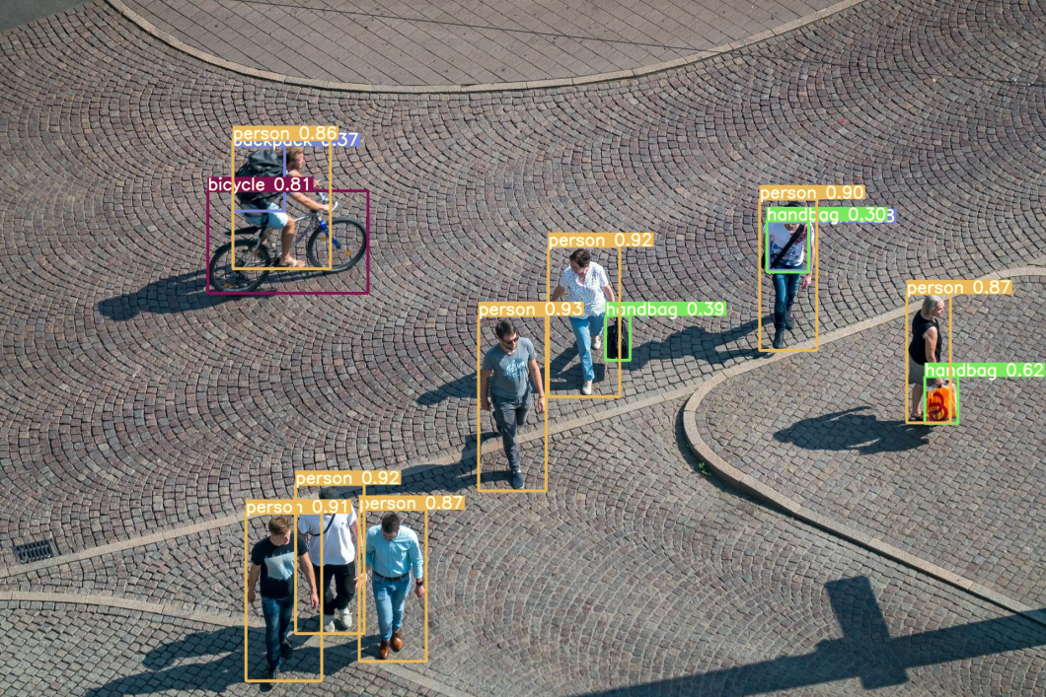YOLOV5 MODEL FOR OBJECT DETECTION Top of Form

Fig2.6.1 YOLOV5 Model for object detection

## 3. ANALYSIS

**3.1 Scope of the project:**

This project encompasses the development of a comprehensive system aimed at enhancing traffic enforcement capabilities. The project begins with a clear definition of objectives, focusing on the automatic detection of helmet usage among motorcyclists and the recognition of license plates. Extensive research and planning are conducted to determine the most suitable technologies and methodologies, with YOLOv5 identified as the preferred object detection model for its real-time processing capabilities. Data collection involves assembling a diverse dataset of images and videos containing relevant scenarios, which undergo preprocessing to ensure optimal training conditions.

Algorithms are developed to determine helmet usage and generate instant challans for violations, incorporating logic for capturing relevant information and issuing fines promptly. Rigorous testing and evaluation are conducted to assess the system's performance across various real-world scenarios. Deployment involves placing the system in relevant environments such as traffic intersections or police checkpoints, alongside documentation and training for end-users to ensure effective utilization. Ethical and legal considerations are carefully addressed throughout the process, emphasizing privacy, fairness, and compliance with relevant regulations.

Finally, the system is designed to be scalable and adaptable for future enhancements, ensuring its long-term viability and effectiveness in enhancing traffic safety and enforcement efforts.

### 3.2 Analysis

The project's strengths lie in its potential to improve road safety. By automatically identifying riders without helmets, it can encourage helmet use and potentially lead to a reduction in motorcycle accident fatalities. Additionally, the use of YOLOv8, a powerful deep learning model, allows for real-time processing, efficiently detecting helmets, license plates, and possible violations. Furthermore, automation streamlines challan generation, reducing manual work and potentially improving both accuracy and speed

Operational efficiency is another critical aspect to consider. The project aims to enhance operational efficiency for traffic authorities by automating the process of violation detection and enforcement. Efficient integration with existing infrastructure, such as traffic management systems and surveillance cameras, is crucial for seamless operation.

.

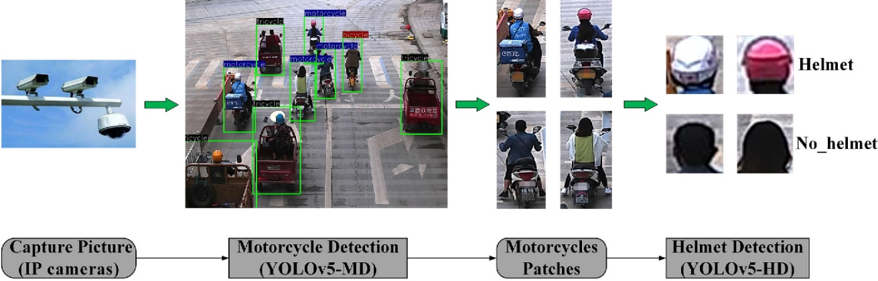

Fig 3.2.1 Helmet Detection &License plate Extraction

**3.3 Existing System:**

The existing system utilizes YOLOv5, a deep learning model known for its speed and accuracy in object detection tasks. It can automatically detect helmets and license plates in real-time with high precision, reducing the need for manual intervention. YOLOv5 is capable of handling large volumes of traffic efficiently, making it suitable for deployment in busy areas such as roads, highways, or parking lots. The proposed system can significantly reduce the time and resources required for monitoring and enforcing helmet and license plate regulations.

By leveraging deep learning techniques, the proposed system can adapt to different environmental conditions and variations in helmet and license plate appearances, improving overall detection performance. It can potentially integrate with existing surveillance systems or traffic management systems to enhance overall traffic safety and enforcement measures

**Disadvantages**:

1. **Dependency on Training Data:** YOLOv5 requires large amounts of anotated training data to perform effectively. Obtaining such datasets can be time-consuming and expensive.
2. **Hardware Requirements:** YOLOv5 may require powerful hardware resources for realtime inference, which could increase the cost of deployment, especially in resourceconstrained environments.

**3.Fine-tuning Complexity:** Fine-tuning YOLOv5 for specific use cases, such as helmet and license plate recognition, might require expertise in deep learning and computer vision, posing challenges for implementation and maintenance.

**3.4 Proposed System:**

The proposed system utilizes YOLOv5, a state-of-the-art deep learning model known for its accuracy and efficiency in object detection tasks. It can automatically detect helmets and license plates in real-time with high accuracy, reducing the need for manual intervention. YOLOv5 is capable of handling large volumes of traffic efficiently, making it suitable for deployment in busy areas such as roads, highways, or parking lots.

The proposed system can significantly reduce the time and resources required for monitoring and enforcing helmet and license plate regulations. By leveraging deep learning techniques, the proposed system can adapt to different environmental conditions and variations in helmet and license plate appearances. It can potentially integrate with existing surveillance systems or traffic management systems to enhance overall traffic safety and enforcement measures.

**Advantages** :

1. **High Accuracy:** YOLOv5 offers high accuracy in object detection, ensuring reliable identification of helmets and license plates, reducing false positives and negatives.
2. **Real-time Processing:** YOLOv5 is optimized for real-time inference, enabling swift detection and recognition of helmets and license plates, facilitating timely enforcement actions.
3. **Scalability:** The proposed system can scale effectively to handle varying traffic volumes, making it suitable for deployment in diverse environments ranging from urban streets to highways.
4. **Adaptability:** YOLOv5 can adapt to different environmental conditions and variations in helmet and license plate appearances, enhancing overall detection performance across diverse scenarios.
5. **Efficiency:** The automated nature of the proposed system reduces the reliance on manual intervention, saving time and resources while improving enforcement effectiveness.

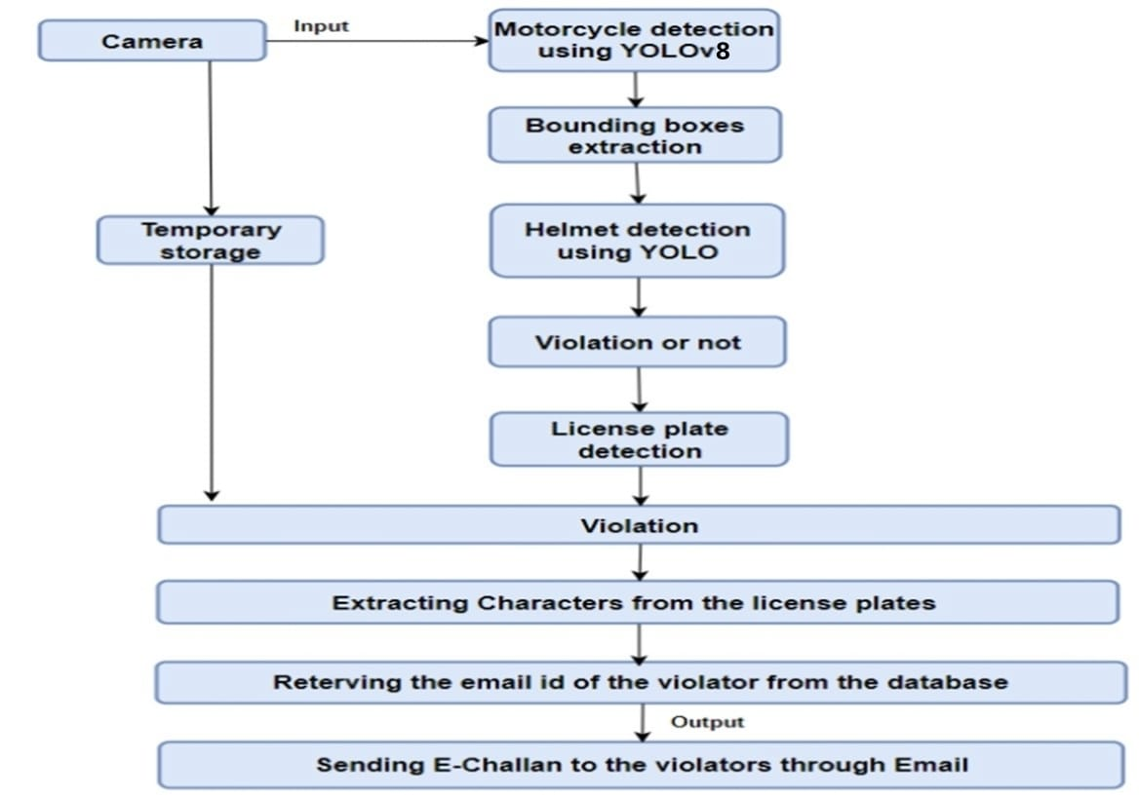

Fig 3.4.1 proposed system model for helmet detection

**3.5 Data Pre-Processing**

Data preprocessing steps in an automatic helmet and license plate recognition project involves illustrating the workflow from image acquisition to data storage and management. Let's break down the process into key diagrams that represent the major steps:

1. **Data Collection and Annotation Workflow**:
   * This diagram will illustrate the process of collecting images, annotating helmets and license plates, and performing data cleaning.
2. **Data Augmentation Techniques**:
   * A visual representation of various data augmentation techniques applied to a single image to showcase how each technique alters the image.
3. **Image Preprocessing Steps**:

* A flowchart showing the sequence of preprocessing steps applied to images before they are fed into

the recognition algorithms. This includes resizing, normalization, and helmet-specific preprocessing.

1. **License Plate Detection and OCR Process**:
   * A diagram illustrating the process of detecting license plates in images and then extracting text from these plates using OCR.

**5.Data Storage and Management**

A schematic representation of how preprocessed images and their annotations are organized and stored.

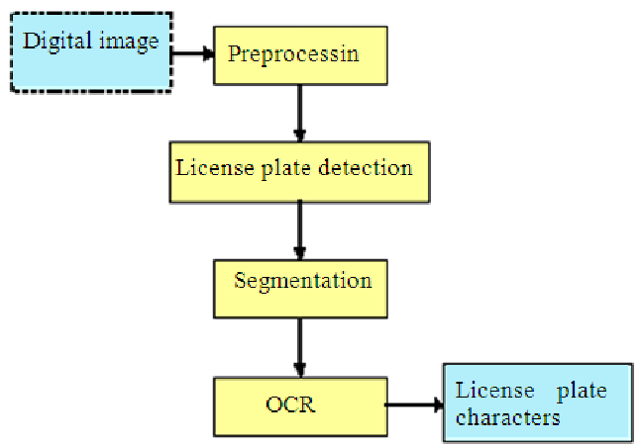

Fig3.5.1 data storage and management

**Image processing**

1. **Gray scaling and Blurring**: As the part of preprocessing the input frame got from the CCTV footage, the image is grayscaled and blurred with the Gaussian Blur method.

**2.Background Subtraction**: The background subtraction method is used to subtract the current frame from the reference frame to get the desired object’s area. The equation shows the method. dst(I) = saturate(|scr1(I) − scr2(I)|)

3**. Binary Threshold**: The binarization method is used to remove all the holes and noises from the frame and get the desired object area accurately.

4. **Dilation and find the contour**: After getting the thresholded image, it is dilated to fill the holes, and the contour is found from the image and it is denoted by the rectangle box.

**3.6 Data Cleaning**

The process involves several critical steps, each designed to refine the dataset and enhance the model's performance.

**Image Quality Assessment** is the first step, where each image in the dataset is evaluated for its clarity, resolution, and relevance. This step ensures that only high-quality images that contribute positively to the model's learning are retained. Images that are blurry, poorly lit, or irrelevant are filtered out to maintain a standard of quality.

Following the quality assessment, **Duplicate Removal** is carried out to eliminate any redundant images. This step is crucial for preventing bias in the model's training process by ensuring a diverse and varied dataset. Duplicate images can skew the model's learning, leading to overfitting and reduced generalizability.

**Noise Reduction and Image Correction** are applied to further refine the images. Techniques such as blurring are used to reduce noise, while corrections are made for images that are skewed or have other distortions. These adjustments help in focusing the model's attention on the relevant features within the images, such as helmets and license plates.

**Region of Interest (ROI) Extraction** is a critical step where specific areas within the images, such as those containing helmets and license plates, are identified and isolated. This process enables the model to focus on the most important parts of the image, improving its ability to recognize and classify these features accurately.

**Data Annotation Correction** involves reviewing and correcting the annotations associated with each image. Accurate annotations are essential for training the model to recognize helmets and license plates correctly. This step ensures that the labels used for training are precise, reflecting the true content of the images.

Finally, **Final Dataset Preparation** organizes the cleaned and processed images into sets for training, validation, and testing. This organization is crucial for the systematic training and evaluation of the model, allowing for the measurement of its performance and the identification of areas for improvement

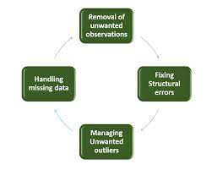

Fig 3.6.1 data cleaning

This includes of five steps like capture of image without helmets and then search for yellow pixels later it will be refined by image filtering . The algorithm used behind for plate region by using smearing algorithm.Line seperation by using row segmentation, characters extraction using column segmentation and OCR for characters recognition.

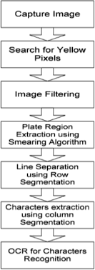

Fig 3.6.2 characters recognition

**3.7 System Requirements**

### Hardware requirements

* Processor - Processor core i3
* Speed - 1.1 GHZ
* RAM – 4GB
* Hard disk - 500 GB
* Monitor - LED Monitor
* Bus Speed : 5 GT/s

### Software Requirements

* Vs Code
* Coding Language : Python 3.10
* SQLite Database
* Operating System: Windows 8 and above
* Python Distribution : GoogleColab

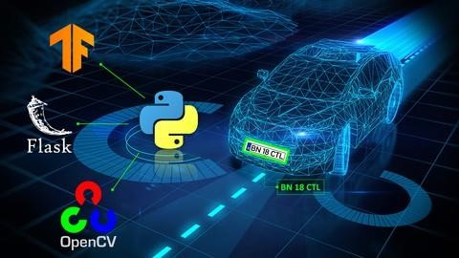

Fig 3.7.1 software requirements

**3.8 FEASIBITLITY STUDY**

A feasibility study is an essential step in assessing the viability and practicality of a proposed system or project. Let us conduct a brief feasibility study for the proposed face detection, age. Estimation, and gender prediction system.

**3.8.1 Economical Feasibility:**

* Cost of Implementation: The use of open-source technologies (OpenCV, Flask) minimizes software costs. Hardware costs for server hosting should be considered but can be optimized using cloud-based solutions.
* Operational Costs: Ongoing operational costs are expected to be minimal, primarily related to server maintenance and hosting.

### 3.8.2 Technical Feasibility

* Availability of Technology: The use of OpenCV, Flask, and pre-trained Convolutional Neural Networks (CNNs) demonstrates technical feasibility. These technologies are well-established and widely used for similar applications.
* System Integration: The integration of pre-trained models for face detection, age, and gender estimation through OpenCV's DNN module showcases technical feasibility. The chosen technologies facilitate smooth system integration.
* Scalability: The system can be scaled by incorporating more advanced or domainspecific pre-trained models for improved accuracy. The use of modular components allows for future enhancements.

### 3.8.3 Social Feasibility

* The aspect of study is to check the level of acceptance of the system by the user. This includes the process of training the user to use the system efficiently. The user must not feel threatened by the system, instead must accept it as a necessity.
* The level of acceptance by the users solely depends on the methods that are employed to educate the

**Operational Feasibility**:

* User Acceptance: The web-based interface enhances user accessibility and acceptability. Real-time face analysis and demographic insights are likely to increase user engagement.
* Training and Support: End-user training requirements are minimal, and support can be provided through documentation and online resources. System administrators may require training for maintenance tasks.

**Legal and Ethical Feasibility**:

* Privacy and Data Protection & Ethical Considerations: Legal compliance with privacy laws and data protection regulations must be ensured, especially given the sensitive nature of facial data. Ethical considerations related to consent and responsible data handling should be addressed.

**Schedule Feasibility**:

* Development Timeline: The feasibility study should estimate the time required for development, testing, and deployment. Consideration of an iterative development approach and realistic timelines is crucial.
* Resource Availability: The availability of skilled developers, data scientists, and system administrators should be considered for on-time project execution. It evaluate the availability of human resources, equipment, and funds necessary to complete the project within the proposed timeline. Assess whether the resources are sufficient and appropriately allocated for each task

Risk Assessment: Identify potential risks and uncertainties that could impact the project schedule, such

As unexpected resource shortages, technical difficulties, or external factors like regulatory changes or

Market fluctuations.

Overall a schedule feasibility brief provides a comprehensive evaluation of the viability of a project

timeline, helping stakeholders make informed decisions and effectively manage project execution.

**4.DESIGN**

4.1 Data Flow Diagram

The design phase in machine learning includes from the pre-processing of the dataset then applying division on the dataset to training and test datasets. Applying the algorithms to fill the missing values. Applying the algorithms to predict the output and finding the best algorithm and conducting the tests on the system by using test dataset.

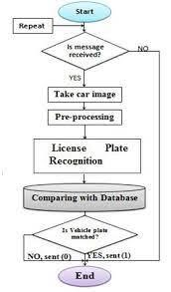

Fig 4.1.1 Fig: Modelling

**5.** **IMPLEMENTATION**

**Introduction to Python** What is Python?

Python is a popular programming language. It was created by Guido van Rossum, and released in 1991. It is used for

* web development (server-side)
* software development
* mathematics
* system scripting.

What can Python do?

* Python can be used alongside software to create workflows.
* Python can connect to database systems. It can also read and modify files.
* Python can be used to handle big data and perform complex mathematics.
* Python can be used for rapid prototyping, or for production-ready software development.

### Matplotlib

This library is responsible for plotting numerical data. And that’s why it is used in data analysis. It is also an open-source library and plots high-defined figures like pie charts, histograms, scatterplots, graphs, etc. **Syntax**

import matplotlib.pyplot as plt

### Pandas

Pandas are an important library for data scientists. It is an open-source machine learning library that provides flexible high-level data structures and a variety of analysis tools. It eases data analysis, data manipulation, and cleaning of data. Pandas support operations like Sorting, Re-indexing, Iteration, Concatenation, Conversion of data, Visualizations, Aggregations, etc. **Syntax** import pandas as pd

### Numpy

The name “Numpy” stands for “Numerical Python”. It is the commonly used library. It is a popular machine learning library that supports large matrices and multi- dimensional data. It consists of in-built mathematical functions for easy computations. Even libraries like TensorFlow use Numpy internally to perform several operations on tensors. Array Interface is one of the key features of this library.

**Syntax**

import numpy as np

### SciPy

The name “SciPy” stands for “Scientific Python”. It is an open-source library used for high-level scientific computations. This library is built over an extension of Numpy. It works with Numpy to handle complex computations. While Numpy allows sorting and indexing of array data, the numerical data code is stored in SciPy. It is also widely used by application developers and engineers. **Syntax**

from scipy import constants

### Implementation of machine learning using python

Python is a popular programming language. It was created in 1991 by Guidovan Rossum. It is used for

* web development(server-side)
* software development
* mathematics • system scripting.

The most recent major version of Python is Python 3. However, Python 2, although not being updated with anything other than security updates, is still quite popular. It is possible to write Python in an Integrated Development Environment, such as Thonny, Pycharm, Netbeans or Eclipse, Anaconda which are particularly useful when managing larger collections of Python files. Python was designed for its readability. Python uses new lines to complete a command, as opposed to other programming languages which often use semicolons or parentheses.

Python relies on indentation, using whitespace, to define scope; such as the scope of loops, functions and classes. Other programming languages often use curly-brackets for this purpose. In the older days, people used to perform Machine Learning tasks manually by coding all the algorithms and mathematical and statistical formula. This made the process time consuming, tedious and inefficient. But in the modern days, it is become very much easy and efficient compared to the olden days by various python libraries, frameworks, and modules. Today, Python is one of the most popular programming languages for this task and it has replaced many languages in the industry, one of the reason is its vast collection of libraries.

Python libraries that used in deep Learning are

* Numpy
* easyocr
* imutils
* cv2
* TensorFlow
* Keras
* PyTorch
* Pandas
* Matplotlib
* os
* Google.colab

**NumPy** is a very popular python library for large multi-dimensional array and matrix processing, with the help of a large collection of high-level mathematical functions. It is very useful for fundamental scientific computations in Machine Learning. It is particularly useful for linear algebra, Fourier transform, and random number capabilities.

High-end libraries like TensorFlow uses NumPy internally for manipulation of Tensors.

**Easyocr** is a very popular library among deep Learning enthusiasts as it is a Python computer Language Optical Character Recognition module that is both flexible and easy to use. OCR technology is useful for a variety of tasks, including data entry automation and image analysis. It enables computers to identify and extract text from photographs or scanned documents.

**imutils** is one of the most popular deep Learning libraries for classical deep Learning algorithms. It is built on top of two basic Python libraries, A series of convenience functions to make basic image processing functions such as translation, rotation, resizing, skeletonization, displaying Matplotlib images, sorting contours, detecting edges, and much more easier with OpenCV

**CV2** is a popular python library that is used to define, evaluate and optimize mathematical expressions involving multi-dimensional arrays in an efficient manner. CV2 is powerful library for working with images in python . In this article, we have covered some of the most commonly used functions and methods in CV2, including image loading and display, image manipulation, and image filtering.

**TensorFlow** is a very popular open-source library for high performance numerical computation developed by the Google Brain team in Google. As the name suggests, Tensorflow is a framework that involves defining and running computations involving tensors. It can train and run deep neural networks that can be used to develop several AI applications. TensorFlow is widely used in the field of deep learning research and application.

**Keras** is a very popular Machine Learning library for Python. It is a high - level neural networks API capable of running on top of TensorFlow, CNTK, or Theano.It can run seamlessly on both CPU and GPU. Keras makes it really for ML beginners to build and design a Neural Network. One of the best thing about Keras is that it allows for easy and fast prototyping.

**PyTorch** is a popular open-source Machine Learning library for Python based on Torch, which is an open-source Machine Learning library which is implemented in C with a wrapper in Lua. It has an extensive choice of tools and libraries that supports on Computer Vision, Natural Language Processing(NLP) and many more ML programs. It allows developers to perform computations on Tensors with GPU acceleration and also helps in creating computational graphs.

**Pandas** is a popular Python library for data analysis. It is not directly related to Machine

Learning. As we know that the dataset must be prepared before training. In this case, Pandas comes handy as it was developed specifically for data extraction and preparation. It provides high-level data structures and wide variety tools for data analysis. It provides many inbuilt methods for groping, combining and filtering data.

**Matpoltlib** is a very popular Python library for data visualization. Like Pandas, it is not directly related to Machine Learning. It particularly comes in handy when a programmer wants to visualize the patterns in the data. It is a 2D plotting library used for creating 2D graphs and plots. A module named pyplot makes it easy for programmers for plotting as it provides features to control line styles, font properties, formatting axes, etc. It provides various kinds of graphs and plots for data visualization, histogram, error charts, bar chats, etc.

**OS** Python has a built-in os module with methods for interacting with the operating system, like creating files and directories, management of files and directories, input, output, environment variables, process management, etc. The os module has the following set of methods and constants.

**Google.colab** Google Colaboratory, or Colab, is an as-a-service [version of Jupyter](https://www.techtarget.com/searchaws/video/Set-up-a-Jupyter-notebook-on-AWS-with-this-tutorial)

[Notebook](https://www.techtarget.com/searchaws/video/Set-up-a-Jupyter-notebook-on-AWS-with-this-tutorial) that enables you to write and execute [Python](https://www.techtarget.com/whatis/definition/Python) code through your browser. Jupyter Notebook is a free, open source creation from the Jupyter Project. A Jupyter notebook is like an interactive laboratory notebook that includes not just notes and data, but also code that can manipulate the data. The code can be executed within the notebook, which, in turn, can capture the code output.

### SMTP

* The free SMTP server that Gmail employs is open to use by anybody on the earth. It enables you to manage email-related tasks from your Gmail account using email clients or internet apps. Email clients are the mail applications that consumers utilise. Among the most popular are Thunderbird, Outlook, and Mac Mail. Since smtp.gmail.com is the default Gmail SMTP server name, you may configure any third-party email software to send messages if you use it.The email platform communicates with the SMTP server by connecting over certain email ports.
* An SMTP port is a location where emails may be sent over the internet. Gmail makes use of the safe SMTP ports 465 and 587. To use the SMTP service provided by Gmail, you would need to sign up for a free account. You may modify the aforementioned parameters on any email program if you already have a Gmail account. This allows you to use your Gmail account to send messages from a variety of gadgets.

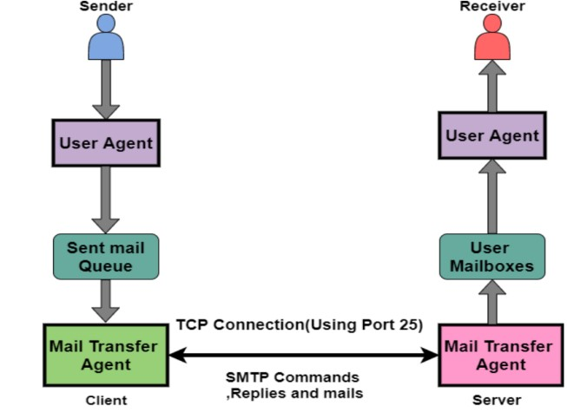

**Fig5.1:** shows the Architecture of SMTP

**Sample code:**

### Training the model using the dataset Installing libraries

!pip install easyocr

!pip install imutils

### Import the libraries

import cv2 import numpy as np import os import imutils from keras.models import load_model from google.colab.patches import cv2_imshow from matplotlib import pyplot as plt

import numpy as np import imutils import easyocr

**loading dataset:**

!pip install roboflow

from roboflow import Roboflow rf = Roboflow(api_key="xxxxxxxxxxxxxxxxxxxx") project = rf.workspace("project-55z6h").project("traffic_offenders") dataset = project.version(2).download("yolov8")

**Training and saving the model:**

!pip install -r requirements.txt !pip install ultralytics import torch from ultralytics import YOLO

!pip install dill import dill model = YOLO("yolov8n.pt")

model.train(data="/content/Licence-Plate-Detection-using-YOLO-

V8/TRAFFIC_OFFENDERS-2/data.yaml", epochs=5)

import torch torch.save(model.model.state_dict(),

'/content/drive/MyDrive/trained_yolov8_model.pt')

config = {

'data_config': '/content/dataset/data.yaml',

'model_architecture': 'YOLOv8',

'training_params': {

'epochs':5

} import torch import json model_weights_path = '/content/drive/MyDrive/trained_yolov8_model.pth' config_path = '/content/drive/MyDrive/trained_yolov8_config.cfg' torch.save(model.model.state_dict(), model_weights_path)

with open(config_path, 'w') as config_file:

json.dump(config, config_file)

**Code to detect the object:**

from google.colab import drive drive.mount('/content/drive')

os.environ['TF_FORCE_GPU_ALLOW_GROWTH'] = 'true'

net = cv2.dnn.readNet("/content/drive/MyDrive/project/Helmet and Number Plate

Detection and Recognition/yolov8-custom_7000.weights",

"/content/drive/MyDrive/project/Helmet and Number Plate Detection and Recognition/yolov8-custom.cfg") net.setPreferableBackend(cv2.dnn.DNN_BACKEND_CUDA) net.setPreferableTarget(cv2.dnn.DNN_TARGET_CUDA) model = load_model('/content/drive/MyDrive/project/Helmet and Number Plate Detection and Recognition/helmet-nonhelmet_cnn.h5') print('model loaded!!!')

cap = cv2.VideoCapture('/content/drive/MyDrive/project/Helmet and Number Plate

Detection and Recognition/video.mp4') COLORS = [(0,255,0),(0,0,255)] layer_names = net.getLayerNames() output_layers = [layer_names[i - 1] for i in net.getUnconnectedOutLayers()] fourcc = cv2.VideoWriter_fourcc(*"XVID") writer = cv2.VideoWriter('output.avi', fourcc, 5,(888,500)) def helmet_or_nohelmet(helmet_roi): try:

helmet_roi = cv2.resize(helmet_roi, (224, 224)) helmet_roi = np.array(helmet_roi,dtype='float32') helmet_roi = helmet_roi.reshape(1, 224, 224, 3) helmet_roi = helmet_roi/255.0 return int(model.predict(helmet_roi)[0][0]) except:

pass

ret = True while ret:

ret, img = cap.read()

img = imutils.resize(img,height=500) height, width = img.shape[:2] blob = cv2.dnn.blobFromImage(img, 0.00392, (416, 416), (0, 0, 0), True, crop=False) net.setInput(blob) outs = net.forward(output_layers) confidences = [] boxes = [] classIds = [] for out in outs: for detection in out:

scores = detection[5:] class_id = np.argmax(scores) confidence = scores[class_id] if confidence > 0.3:

center_x = int(detection[0] * width) center_y = int(detection[1] * height) w = int(detection[2] * width) h = int(detection[3] * height) x = int(center_x - w / 2) y = int(center_y - h / 2) boxes.append([x, y, w, h]) confidences.append(float(confidence)) classIds.append(class_id) indexes = cv2.dnn.NMSBoxes(boxes, confidences, 0.5, 0.4) for i in range(len(boxes)): if i in indexes:

x,y,w,h = boxes[i] color = [int(c) for c in COLORS[classIds[i]]] if classIds[i]==0:

helmet_roi =

img[max(0,y):max(0,y)+max(0,h)//4,max(0,x):max(0,x)+max(0,w)] else:

x_h = x-60 y_h = y-350 w_h = w+100 h_h = h+100 cv2.rectangle(img, (x, y), (x + w, y + h), color, 7) if y_h>0 and x_h>0:

h_r = img[y_h:y_h+h_h , x_h:x_h +w_h] c = helmet_or_nohelmet(h_r)

cv2.putText(img,['helmet','no-helmet'][c],(x,y-

100),cv2.FONT_HERSHEY_SIMPLEX,2,(0,255,0),2)

cv2.rectangle(img, (x_h, y_h), (x_h + w_h, y_h + h_h),(255,0,0), 10)

if c == 1:

cropped_image = img[y:y+h , x:x+w] cv2_imshow(cropped_image) reader = easyocr.Reader(['en'])

result = reader.readtext(cropped_image) text = "" for i in result: text += i[1] + " " write_to_excelsheet(text,li[temp]) temp+=1 temp=temp%3 print(text) writer.write(img) cv2_imshow(img) if cv2.waitKey(1) == 27: break writer.release() cap.release() cv2.waitKey(0) cv2.destroyAllWindows()

def write_to_excelsheet(text,mailid): file_path = '/content/drive/My Drive/data.xlsx' df = pd.read_excel(file_path) new_row={'hello':text,'email_id':mailid} df.loc[len(df)] = new_row `

df.to_excel(file_path, index=False)

**Email sender code**:

function sendAutomaticEmail() {

var sheet = SpreadsheetApp.getActiveSpreadsheet().getActiveSheet();

var dataRange = sheet.getDataRange();

var data = dataRange.getValues();

for (var i = 1; i < data.length; i++) {

var emailAddress = data[i][0]; // Assuming email addresses are in the first column (A)

var condition = data[i][1]; // Assuming the trigger condition is in the second column (B)

if (condition === "Trigger") {

var subject = 'Request to pay challana';

var message = ‘Hi!! It is to mention that you were detected without Helment. And here by requested to pay challan of 500/- with in two days of receiving it. Thank You!’;

MailApp.sendEmail(emailAddress, subject, message);

}

}

}

## 6.TESTING

**TEST CASES**

### Unit Testing

Unit testing involves the design of test cases that validates that the internal program logic is functioning properly, and that program inputs produce valid outputs. All decision branches and internal code flow should be validated. It is the testing of individual software units of the applications. It is done after the completion of an individual unit before integration.

### Integration Testing

Integration tests are designed to test integrated software components to determine if they actually run as one program. Testing is event driven and is more concerned with the basic outcome of screens or fields. Integration tests demonstrate that although the components were individually satisfaction, as shown by successfully unit testing.

### Validation Testing

An engineering validation test is performed on first engineering prototypes, to ensure that the basic unit performs to design goals and specifications. It is important in identifying design problems, and solving them as early in then design cycle as possible, is the key to keeping projects on time and within budget. Verification is a quality control process that is used to evaluate whether or not a product, service, or system compiles with regulation, specifications, or conditions imposed at the start of a development phase. Validation is a quality assurance process of establishing evidence that provides a high degree of assurance that a product, service, or system accomplishes its intended requirements.

**System Testing**

System testing of software or hardware is testing conducted on completed integrated system to evaluate the system’s compliance with its specified requirements.

System testing falls within the scope of black box testing, and as such, should require no knowledge of the inner design of the code or logic. Test cases

Test case 1:

Input : Traffic captured images

Expected behaviour : person uses helmet

Actual behaviour :person uses helmet

Result : Sucess

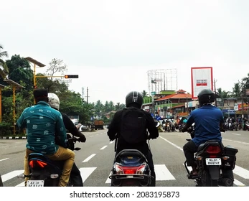

Fig6.1 image for helmet detection

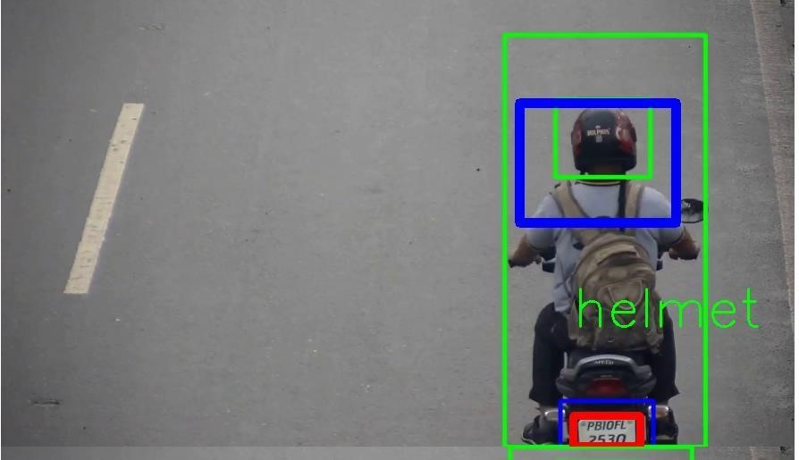

Fig 6.2 helmet detected

Test case 2:

Input : Traffic captured images

Expected behaviour : person uses helmet

Actual behaviour :person not used helmet

Result : Sucess

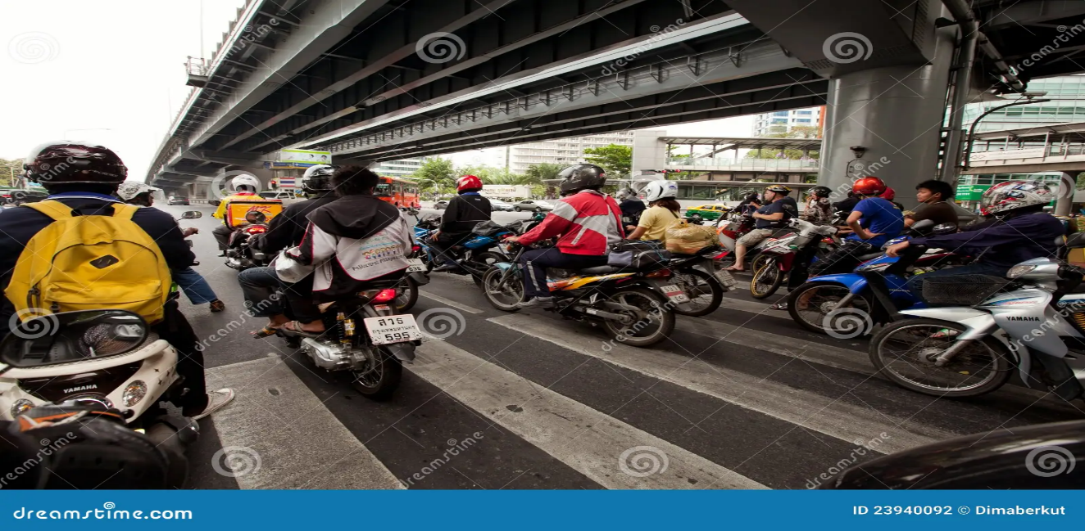

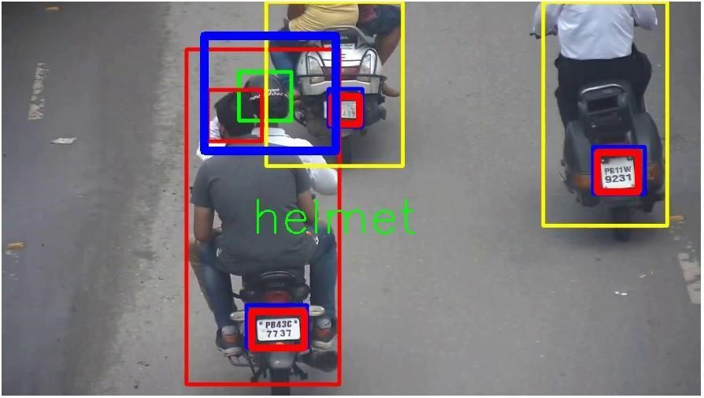Fig 6.2 captured images for detection

Fig 6.2.1 helmet detected

Test case 3:

Input : Traffic captured images

Expected behaviour : person uses helmet

Actual behaviour :person uses helmet

Result : failure

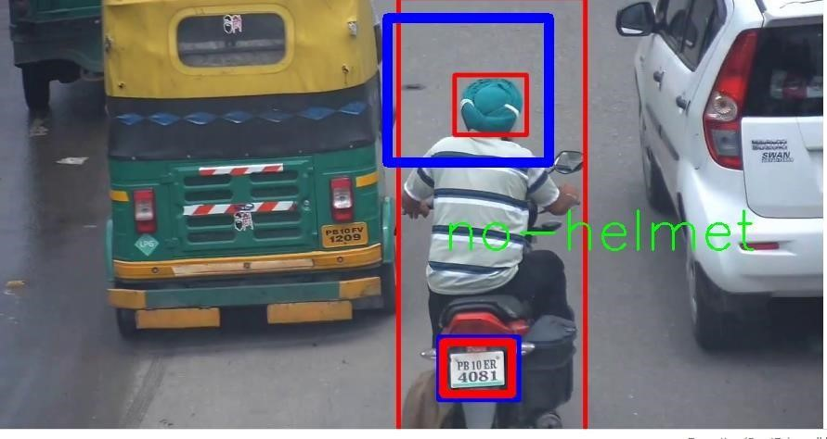

Fig 6.3 captured image at traffic

**7.OUTPUTSCREENS**

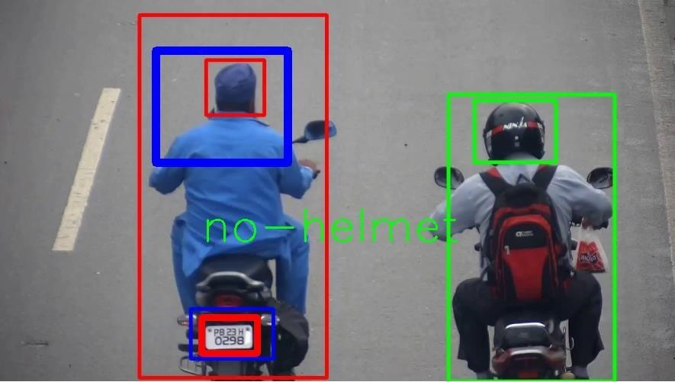

**Fig7.1 identifying a person who has no helmet**



**Fig7.2 detected person with a helmet**

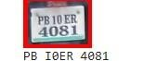

**Fig7.3 extracting the text from the number plate**

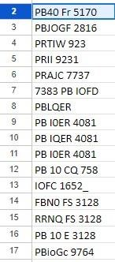

**Fig7.4 storing the extracted number plate in a file**

**8.CONCLUSION & FUTURE SCOPE**

It is a fact that with the raise in population, and the evolution of new technology, the introduction of automobiles have a great impact in society. As the number of Vehicles increased, there might be equal chances of accidents. The people are not much particular about the rules and they violate them. The riders without helmets must be caught. There are existing systems that are used to detect the rider without a helmet, but some require human assistance. Hence the proposed Objectives were developed using YOLOv5 which works more effectively compared to other models. The experimental results specify the projected approach can identify the rider without a helmet and extract the license plate, recognize the text from the license plate using Tesseract OCR, extracts the vehicle details that are stored in the MYSQL database, and finally send sms using SMTP module to the violator regarding the challan instantly. Out of 25 real-time license plate images captured our model successfully recognized 17 plates characters accurately.

The technology increases efficiency , decreases the need of human involvement, and encourages .Compliance with traffic laws by automating these functions. Convenience and transparency are furthers improved by the system’s capacity to alert car owners of infractions and provide online payment alternate alternatives. All things considered, the suggested strategy helps to promote safe driving conditions and efficient traffic control tactics. Road safety and adherence to traffic laws could be significantly improved with the further development and use of such systems.

The project successfully addressed the challenge of simultaneous detection of helmets and license plates, crucial for traffic safety and laws enforcement.

**9.REFERENCES**

1. Dr.Sonali Ridhorkar, K.l.P.B.V.M.V. Khushi Gupta: Online challan generation system based on machine learning. International Journal of Innovations in Engineering and Science 7, 120–25 (2022)
2. Islam, N., Islam, Z., Noor, N.: A Survey on Optical Character Recognition System. Journal of Information Communication Technology (JICT) 10(2), 4 (2016)
3. Jin, Z., Qu, P., Sun, C., Luo, M., Gui, Y., Zhang, J., Liu, H.: DWCA-YOLOv5: An Improve Single Shot Detector for Safety Helmet Detection. Journal of Sensors 2021, 1– 12 (2021) https://doi.org/10.1155/2021/4746516
4. Chavan, G., Khot, M., Kamble, P.: E-Challan Generation using QR code. International

Journal of Advance Research, Ideas and Innovations in Technology 6(2), 290–292 (2020)

1. Shubham Kumar Chandravanshi, M.D.H.T. Hirva Bhagat: Automated generation of challan on violation of traffic rules using machine learning. International Journal of Science and Research (IJSR) 10, 1157–1162 (2021)
2. N Jichkar, A.T.S.B.S.V. A Deulkar: International journal of research in engineering, science and management (ijresm) 2 (2019)
3. Olaleye, O., Olaniyan, A., Eboda, O., Awolere, A.: SMS-Based Event Notification System. Journal of Information Engineering and Applications 3(10), 55–61 (2013)
4. Thombre, W.S.S.T.R.R.S.Z.S..D.S. S. S.: Automated traffic rule violation detection with e-challan generation for smart societies. Decision Analytics for Sustainable Development in Smart Society 5.0: Issues, Challenges and Opportunities, 65–81 (2022)
5. Dhage, P.G.V.M.S.J.T.P.N..N.P.H. M. R.: Automatic traffic e-challan generation using computer vision. Sustainable Communication Networks and Application, 203–213 (2020)
6. Dhage, M.R., Patil, G., Mistry, S.J., Tambe, P.N., Nankar, P.: Automatic Traffic Echallan Generation Using Computer Vision. Lecture notes on data engineering and communications technologies, 203–213 (2019) https://doi.org/10.1007/ 978-3-03034515-0
7. Geng, Rui, et al. An Improved Helmet Detection Method for YOLOv3 on an Unbalanced

Dataset. 2021 3rd International Conference on Advances in Computer Technology, Information Science and Communication (CTISC), Apr. 2021, https://doi.org/10.1109/ctisc52352.2021.00066.

1. Khare, Vijay, et al. Helmet Detection Using Yolo -V3 Technique. International Journal of Trend in Scientific Research and Development (IJTSRD), vol. 6, no. 2, Jan. 2022, p.

986.

1. Sanjana, S., et al. A Review on Various Methodologies Used for Vehicle Classification, Helmet Detection and Number Plate Recognition. Evolutionary Intelligence, vol. 14, no.

2, Springer Science+Business Media, June 2021, pp. 97987.

1. Charlie, Noel. Automatic Helmet Detection System on Motorcyclists Using YOLOv3. International Journal for Research in Applied Science and Engineering Technology, International Journal for Research in Applied Science and Engineering Technology (IJRASET), May 2020, [.](https://doi.org/10.22214/ijraset.2020.5464)
2. Kathane, M., Abhang, S., Jadhavar, A., Joshi, A. D. Sawant, S. T. (2022). Traffic rule violation detection system: deep learning approach. In Advanced Machine Intelligence and Signal Processing (pp. 191-201). Singapore: Springer Nature Singapore.
3. https://medium.com/@balaajip/optical-character-recognition-99aba2dad314
4. https://s3.ap-south 1.amazonaws.com/s3.studytonight.com/tutorials/uploads /pictures/1611985889-71449.png
5. Srivastava, A., Bhardwaj, S. Saraswat, S. (2017, May). SCRUM model for agile methodology. In 2017 International Conference on Computing, Communication and Automation (ICCCA) (pp. 864-869). IEEE. [20] Nepal, U.; Eslamiat, H. Comparing

YOLOv3, YOLOv4 and YOLOv5 for Autonomous Landing Spot Detection in Faulty UAVs. Sensors 2022, 22, 464. https://doi.org/10.3390/s22020464

1. Yusro, Muhamad Munawar, Rozniza Ali, and Muhammad Suzuri Hitam. ”Comparison of Faster R-CNN and YOLOv5 for Overlapping Objects Recognition.” Baghdad Science Journal (2022).
2. Chen, S., Chen, B. (2022, March). Research on object detection algorithm based on improved Yolov5. In Artificial Intelligence in China: Proceedings 49 of the 3rd International Conference on Artificial Intelligence in China (pp. 290-297). Singapore: Springer Singapore.
3. J. Memon, M. Sami, R. A. Khan and M. Uddin, ”Handwritten Optical Character

Recognition (OCR): A Comprehensive Systematic Literature Review (SLR),” in IEEE Access, vol. 8, pp. 142642-142668, 2020, doi: 10.1109/ACCESS.2020.3012542.

1. Patel, C., Patel, A., Patel, D. (2012). Optical character recognition by open source OCR tool tesseract: A case study. International Journal of Computer Applications, 55(10), 50-56.

AUTOMATIC HELMET AND LICENSE PLATE RECOGNITION USING YOLOV5 WITH INSTANT E-CHALLAN INTIMATOR

|  |  |  |  |
| --- | --- | --- | --- |
| Siva Nageshwarao | Y.Saketh Kumar | B.Ranga Sai Karthik | K.Manikya Rao |
| Department of Computer Science and Engineering | Department of Computer Science and Engineering | Department of Computer Science and Engineering | Department of Computer Science and Engineering |
| Narasaraopeta Engineering College | Narasaraopeta Engineering College | Narasaraopeta Engineering College | Narasaraopeta Engineering College |
| Narasaropeta | Narasaropeta | Narasaropeta | Narasaropeta |
| [profssnr@gmail.com](mailto:profssnr@gmail.com) | [ysaketh1902@gmail.com](mailto:ysaketh1902@gmail.com) |  |  |

# Abstract

The main form of transportation in developing nations has always been motorcycles. The number of motorcycle accidents has increased in the last several years. Not donning a protective helmet is one of the main causes of fatalities in motorcycle accidents. Traffic police manually observing motorcyclists at intersections or using CCTV footage to penalize those who do not wear helmets is the most common way. However, it necessitates human involvement and work. This study suggests an automated method for identifying riders who do not wear helmets and obtaining their license plates from security camera footage. In order to obtain moving objects, the suggested approach first subtracts the background from the video. Next, moving items are categorized as either non-motorcyclist or motorcyclist. The head section of a biker is categorized as either helmet or non-helmet. Lastly, the motorcycle number plate of the indicated rider without a helmet is found, and the characters on it are extracted. The proposed system utilizes YOLOv5 for detecting motorcyclists without helmets in traffic videos.

**Keywords:** Motorcycle, Helmet, License plates, CCTV, YOLOv5.

1. **INTRODUCTION**

One of the most important safety equipment for motorcycle riders is a helmet.

Regretfully, their use has not risen, especially in areas where helmet-free policies are strictly enforced. This technique aims to give an automated system approach to identify motorcycle riders who wear helmets and those who do not, along with the number plates that relate to each. According to the World Bank, 1 percent of all road deaths worldwide usually occur in India, where there are 1% of cars. According to a December 2018 analysis by the Mumbai Environmental Social Network, the percentage of road occupied by buses has slightly decreased from 6.2 percent to 2.2 percent, however the percentage of space occupied by private automobiles has increased over the past 20 years from 59 percent to 77 percent. The Government of India has proposed the Various Penalties under Motor Vehicles (Amendment) Bill - 2019 in an effort to encourage the use of helmets. A biker who violates section 194D will be fined Rs. 1000 and have their license revoked for three months.

At the moment, traffic police manually keep an eye on motorcycle riders, helmet or not. Manual verification is insufficient, time-consuming, and subject to human mistake. Furthermore, human labor is needed in large semi-urban and rural areas where CCTV surveillance-based approaches are not automated.

The exponential increase in motorcycle- related traffic accidents in recent years has highlighted the critical need for efficient enforcement and surveillance measures. Conventional approaches to oversight and implementation have been shown to be insufficient. Thus, utilizing cutting-edge computer vision methods like OCR and YOLOv5 appears to be a viable way to deal with

With urgent problem. Our suggested method is a multi-step procedure. First, footage is taken via CCTV cameras that are placed at key spots. Then, sophisticated background removal methods are used to extract the important components from the frame, improving the precision of the analysis that follows. The identification of motorcycle riders and their lack of helmets is the main focus of our investigation. By accurately locating and examining the region of interest that corresponds to the motorcyclist's head in the video frame, this crucial duty is completed. When a rider without a helmet is identified, our system's optical character recognition (OCR) component kicks in to extract and identify the license plate data. This data is essential supporting documentation for further enforcement proceedings. Our method provides a reliable and effective way to improve road safety measures by integrating OCR for text recognition and YOLOv5 for object detection in a seamless manner. This paper's practical ramifications for real-world applications—particularly in the areas of law enforcement and traffic management—are what make it significant. By utilizing state-of-the-art technologies, we hope to support the creation of preventative measures that lessen the hazards connected to motorcycle riders' failure to wear helmets.

# RELATED WORK

A solution to the problem of motorcycle detection in surveillance footage was put out by **Chiu et al[7].** This system divides

the moving item into segments, and then uses a probability-based method to track motorcycles and heads. This approach handles the occlusion issue, but it is not able to handle minute deviations caused by noise and lighting effects. Additionally, it detects heads using Canny edge detection inside a specific search window size. To identify motorcycle riders, Chiverton et al. employed characteristics based on edge histograms**.**

**P. Doungmala et al.[1]** published two strategies for full and half helmet detection in which has been the subject of numerous approach algorithms for many years. They detected whole helmets using the Haar feature extractor and partial helmets using the circular hough transform. Recall was accomplished in the experiments using images, with a score of 95.

**Dhwani et al.[2]** presented a method for identifying motorcycle riders who were not wearing helmets. Through thresholding, the system was able to identify moving cars. Using aspect ratio and area, they then divided the population into motorcyclists and non-motorcyclists. First, a zone of interest is identified in order to detect helmets.

To get beyond a few obstacles At the power substation, **J. Li et al. [3]** detected the presence of helmets with an accuracy of

80.7 percent. To find moving items, they applied the ViBe background subtraction technique. To identify helmets, they employed an SVM classifier and an Oriented Gradient Histogram after obtaining the region of interest.

**K. C. D. Raj et al.[4]** created a machine system in [9] that can both detect and recognize number plate characters and motorcyclists riding without a helmet. They employed convolutional neural networks with Alexnet that were based on deep learning. They detected with good precision.

**N. Boonsirisumpun et al.[5]** suggested a strategy to use four different CNN

models—GoogLeNet, VGG19, VGG16, and Mobilenet—in combination with a single shot multibox detector to recognize people riding bikes with or without helmets in videos. Of these, Mobilenet performed the best.

**Kai et al.[6]** employed a Tensorflow model and a deep learning technique to identify individuals at power substations. After that, they recognized helmets using color space transformation in HSV color space. Videos were used for the experiments. The overall detection accuracy of the system was 89.0 percent.

1. **PROPOSED MODEL**

# Helmet and License Plate Recognition

* + 1. **Input Acquisition**

The key input for the model is CCTV footage that records traffic activity on the roads. To improve clarity and eliminate noise, the film is gathered and pre- processed.

* + - 1. Gathering CCTV Video

CCTV footage of traffic activity is continuously recorded by cameras placed strategically at major roads, crossroad and other high-traffic areas. To guarantee the models resilience and flexibility, footage is gathered during different hours of the day and in different weather conditions.

* + - 1. Camera Alignment and Calibration:

To standardize camera properties such as perspective, lens distortion and focal length, calibration methods are put into place. The uniformity of the object scale and spatial connections among various camera feeds is guaranteed by the alignment of camera viewpoints.

* + - 1. Optimization of Resolution and Frame Rate:

CCTV cameras are set up to record video at the best frame rates and resolutions possible in order to balance the need for data storage with the quality of the images. Elaborating analysis is made possible by high- resolution video, and accurate object

detection requires smooth motion recording, which is ensured by sufficient frame rates.

* + - 1. Preprocessing Input:

To improve the quality of recorded video, preprocessing methods including denoising filters and contrast enhancement algorithms are used. Reducing noise increases object clarity and boosts the efficiency of later computer vision algorithms.

# Background Removal

The background reduction step is essential for separating out significant objects and improving the precision of tasks that follow in terms of detection and recognition. In Order to differentiate between stationary background items and moving objects like cars, bikes and pedestrians background subtraction techniques like CNN in deep learning are used.

**CNN (Convolution Neural Networks)** One kind of deep learning algorithm that works especially well for tasks involving picture recognition and processing is the convolutional neural network (CNN). Convolutional, pooling, and fully connected layers are some of the layers that make it up. The human brain's visual processing served as the inspiration for CNN architecture, which makes them ideal for identifying spatial connections and hierarchical patterns in images.

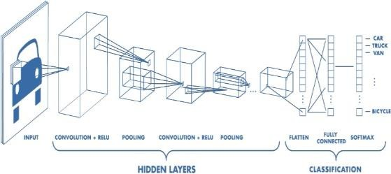

Fig-3.1.2.1 CNN

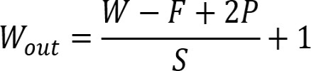

# Helmet Detection Using YOLOv5

Motorcycle riders in the divided areas are identified by their helmets using YOLOv5. When there is no helmet, the model detects this and stores it for further analysis.YOLOv5 can Identify multiple vehicles and detect whether driver is having Helmet or not as shown in Figure 3.1.3.3. **YOLOv5**

YOLOv5 is a computer vision model that belongs to the You Only Look Once (YOLO) family. YOLOv5 is a popular object detection tool. There are four primary variants of YOLOv5, each offering progressively higher accuracy rates: small (s), medium (m), large (l), and extra large (x). Additionally, the training times for each variety vary.

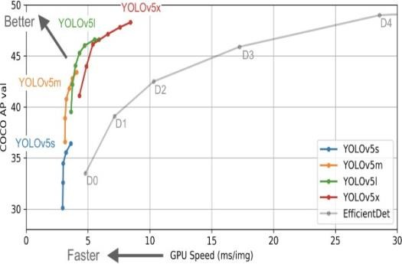

Fig:3.1.3.1 YOLOv5 Speed in Object detection.

Glenn Jocher's YOLOv3 PyTorch repository is a natural progression to the YOLOv5 repository. Developers frequently used the YOLOv3 PyTorch repository to port YOLOv3 Darknet weights to PyTorch before deploying them to production. Many people (including our Roboflow vision team) preferred the PyTorch branch's user- friendliness and would utilize it for deployment. To enable thousands of developers to train and implement their own unique object detectors that can detect

any object in the world, Ultralytics started to make research advancements in addition to repository design modifications after completely duplicating the model architecture and training process of YOLOv3.

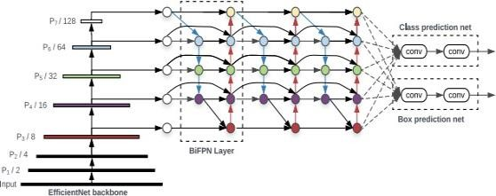

Fig-3.1.3.2 YOLOv5 Architecture.

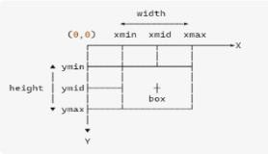

Fig-3.1.3.3 Bounding Box Calculation in YoloV5

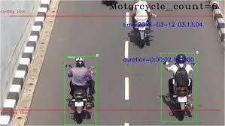

Fig-3.1.3.3 Helmet Detection Using Yolov5.

# License Plate Extraction Using OCR

To extract alphanumeric characters from the divided license plate sections, OCR techniques are used. For the purpose of identifying vehicles and recognizing license plates, extracted characters are processed.

**OCR (Optical Character Recognition)** Optical Character Recognition is referred to as OCR. It is the process that converts a text

image into a computer-readable text format. For example, if you scan an invoice or a receipt, your computer will save the scan as an image file. You cannot use a text editor to edit, search for, or count the phrases in the image file. Using OCR, the image can be converted into a text file and its contents recorded as text.The text on vehicle registration plates will be automatically recognized by the Tesseract OCR, an optical character recognition engine. Python-tesseract

Python-tesseract is an optical character recognition (OCR) tool for the Python programming language. It can thus identify and "read" text that is embedded in photos. A wrapper for Google's Tesseract-OCR Engine is called Python-tesseract. Because it can read all image formats, including jpeg, png, gif, bmp, tiff, and others, it is also utilized as a standalone script. Additionally, Python-tesseract will output the recognized text instead of writing it to a file if used as a script. It is capable of recognizing over 100 different languages.

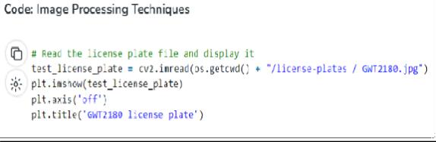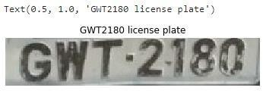

Fig-3.2.1 License-Plate Recognition using Tesseract OCR

# E-Challan Generation

An electronic e-challan is generated based on the owner information and the identified infraction. The timestamp, location, and vehicle details of the infraction are all included in the e-challan, along with the associated penalty.

Notification to Owner of the Vehicle Through electronic communication channels, the vehicle owner is informed of the traffic infraction and the issue of the e- challan. Notifications can be sent via email, mobile application, or SMS, based on the user's choices and the availability of contact information.

Instructions and Payment Options

The available payment alternatives and directions for paying the fine are included in the e-challan message. To offer the bike owner ease and flexibility, payment methods can include mobile wallets, online payment portals, or dedicated payment centers.

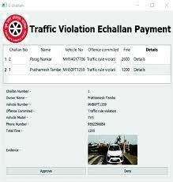

Fig:3.3.1 E-challan

# System Architecture

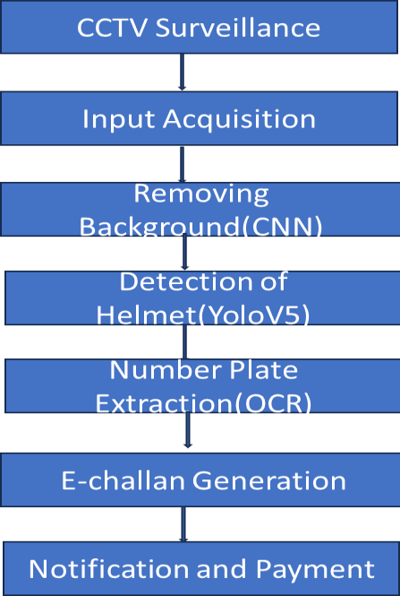

Fig:3.4.1 System Architecture

# RESULTS AND DISCUSSIONS

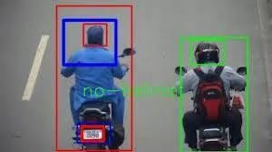

Fig:4.1 Helmet Detection

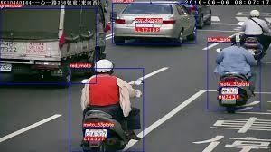

Fig:4.2 Detecting multiple Vehicles

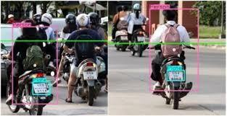

Fig:4.3 License plate Detection

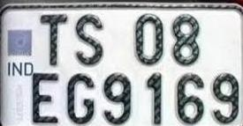

Fig:4.4 License number Extraction using OCR

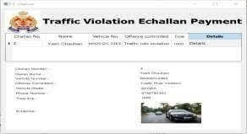

Fig:4.5 Automatic E-challan

# CONCLUSION

The suggested method uses automatic license plate identification and detection of motorcycle riders without helmets to provide a comprehensive approach to improving road safety and traffic law enforcement. The system uses cutting-edge technology like OCR for license plate identification and YOLOv5 for helmet detection to speed up the process of recognizing traffic offenses and issuing e- challans. The technology increases efficiency, decreases the need for human involvement, and encourages compliance with traffic laws by automating these functions. Convenience and transparency are further improved by the system's capacity to alert car owners of infractions and provide online payment alternatives. All things considered, the suggested strategy helps to promote safe driving conditions and efficient traffic control tactics. Road safety and adherence to traffic laws could be significantly improved with the further development and use of such systems.

# REFERENCES

1. In the 2016 IEEE International Conference on Computer and Information Technology (CIT), Nadi, 2016, P. Doungmala and K. Klubsuwan, "Helmet Wearing Detection in Thailand Using Haar Like Feature and Circle Hough Transform on Image Processing," pp. 611-614.
2. The article "Cascade Classifier based Helmet Detection using OpenCV in Image Processing" was published in May 2016 in the National Conference on Recent Trends

in Computer and Communication Technology (RTCCT 2016), by Contractorr, Dhwani, Pathak, Ketki, Sharma, Sonali, Bhagat, Shreya, and Sharma, Tanu.

1. J. Li et al., "Image processing and machine learning based safety helmet wearing detection," 2017 Ninth International Conference on Advanced Computational Intelligence (ICACI), Doha, 2017, pp. 201205.
2. "Helmet violation processing using deep learning," 2018 International Workshop on Advanced Image Technology (IWAIT), Chiang Mai, 2018, pp. 1-4, K. C.

D. Raj, A. Chairat, V. Timtong, M. N. Dailey, and M. Ekpanyapong.

1. he paper "Automatic Detector for Bikers with no Helmet using Deep Learning," presented at the 22nd International Computer Science and Engineering Conference (ICSEC) in Chiang Mai, Thailand in 2018, features a presentation by

N. Boonsirisumpun, W. Puarungroj, and P. Wairotchanaphuttha.

1. Z. Kai and W. Xiaozhi, "Wearing Safety Helmet Detection in Substation," in IEEE IIRC 2019 (Xi'an, China), 2nd International Conference on Electronics and Communication Engineering (ICECE), pp. 206-210.

Motorcycle detection and tracking system with occlusion segmentation," by C.-C. Chiu, M.-Y. Ku, and H.-T. Chen, in Proceedings of the International Workshop on Image Analysis for Multimedia Interactive Services, Santorini, Greece, June 6–8, 2007, pp. 32–32.

"Boosting Object Proposals: From Pascal to COCO," J. Pont-Tuset and L. V. Gool, IEEE International Conference on Computer Vision (ICCV), Santiago, 2015, pp. 1546–15554.

1. "Analysis and Architecture for the deployment of Dynamic License Plate Recognition Using YOLO Darknet," by U. Upadhyay, F. Mehfuz, A. Mediratta, and A. Aijaz, in 2019 International Conference on Power Electronics, Control and Automation (ICPECA), New Delhi, India, pp. 1-6.
2. In 2018, the IEEE International Conference on Big Data was held in Seattle, Washington, USA. Rachel R. Huang, J. Pedoeem, and C. Chen presented their paper, "YOLO-LITE: A RealTime Object Detection Algorithm Optimized for Non- GPU Computers," on pages 2503-2510.
3. "You Only Look Once: Unified, realtime object detection," J. Redmon, S. Divvala, R. Girshick, and A. Farhadi, 2016 IEEE Conference on Computer Vision and Pattern Recognition (CVPR), 2016, pp. 779–788.

AHDANDLUYOLOV5-1.pdf

9

ORIGINALITY REPORT

%

SIMILARITY INDEX

3%

INTERNET SOURCES

7%

PUBLICATIONS

4%

STUDENT PAPERS

PRIMARY SOURCES

1 Fahad A Khan, Nitin Nagori, Ameya Naik. "Helmet and Number Plate detection of Motorcyclists using Deep Learning and Advanced Machine Vision Techniques", 2020 Second International Conference on Inventive Research in Computing Applications (ICIRCA), 2020

Publication

3%

2%

2 Submitted to Liverpool John Moores University

Student Paper

1%

3 Yogiraj Kulkarni, Shubhangi Bodkhe, Amit Kamthe, Archana Patil. "Automatic number plate recognition for motorcyclists riding without helmet", 2018 International Conference on Current Trends towards Converging Technologies (ICCTCT), 2018

Publication

1

ijcsmc.com

Internet Source %

4

6

7

8

9

10

Internet Source

Dikshant Manocha, Ankita Purkayastha, Yatin Chachra, Namit Rastogi, Varun Goel. "Helmet Detection Using ML & IoT", 2019 International Conference on Signal Processing and Communication (ICSC), 2019

Publication

aran.library.nuigalway.ie

Internet Source

e-archivo.uc3m.es

Internet Source

Aphinya Chairat, Matthew N. Dailey, Somphop Limsoonthrakul, Mongkol Ekpanyapong, Dharma Raj K.C.. "Low Cost, High Performance Automatic Motorcycle Helmet Violation Detection", 2020 IEEE Winter Conference on Applications of Computer Vision (WACV), 2020

Publication

Maheswaran S, Gomathi R D, Sathesh S, Deepan Kumar S, Murugesan G, Prakash Duraisamy. "Real-time Implementation of YOLO V5 Based Helmet with Number Plate Recognition and Logging of Rider Data using PyTorch and XAMPP", 2023 14th International

1%

1%

<1%

<1%

<1%

<1%